
28th Dec 2022
Murali Banavoth, Ph.D.
Professor of Chemical Science
Solar Cells and Photonics Research Laboratory
School of Chemistry University of Hyderabad
Hyderabad, Telangana, India, 500046
Phone: +9140 23134828, +91 7981938046
Email: murali.banavoth@uohyd.ac.in

Dear Executive Editor: Prof. Jin Zhong Zhang,

Greetings from the University of Hyderabad, India.

Thank you for your email dated 27, Dec, 2022, regarding our manuscript (ID: jz-2022-033596.R1). We are grateful to the reviewer for recommending the manuscript for publication in the ‘Journal of Physical Chemistry Letters’. We have addressed all the editorial office comments in the revised version of the manuscript.

We sincerely hope that the revised manuscript is now suitable for publication in the Journal of Physical Chemistry Letters. Finally, we are grateful to Journal of Physical Chemistry Letters’ Editorial Office for their support with the reviews/revisions to our manuscript. We hope that you will find our revised manuscript both compelling and publishable in Journal of Physical Chemistry Letters. I look forward to hearing from you soon.
Sincerely,
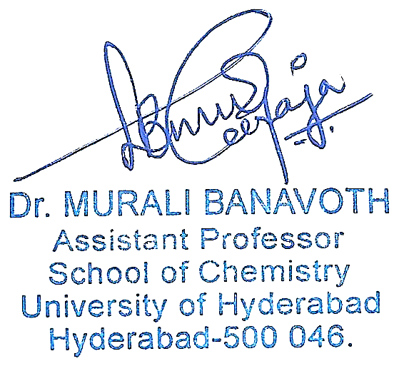
Murali Banavoth, Ph.D

